Archie Hall
Year 1 – ‘STRIKE’ football magazine
Unit 8 – Extended Project
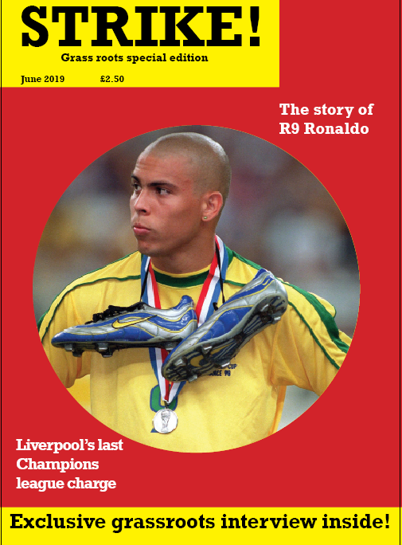

Extended PROJECT PORTFOLIO
Academic Year 2016/2017



CONTENTS

CONTENTS 2
LIST OF FIGURES 2
LIST OF TABLES 2
DEFINITION OF TERMS 2
Unit 8 - Project Proposal 2
2
Project Action Plan and Timetable 2
2
CHAPTER 1 2
Introduction 2
2
The Background of my Project 2
Who am I? 2
What did I learn on my course? 2
What is my project about? 2
Why my project is important? 2
My Research Plan 2
2
CHAPTER 2 2
Literature/Resources Review 2
2
Introduction 2
Media sources, literature search and evaluation Error! Bookmark not defined.
Requirements for my creative media production project 2
CONCLUSION - Who/what was my inspiration? /Contextualisation of my study 2
CHAPTER 3 2
Research Design and Strategies 2
2
Introduction 2
Research Questions 2
Research Design Evolution 2
CHAPTER 4 2
Writing and presenting my research findings 2
2
Findings/Data analysis 2
Conclusion - How did the research help me with my project? (Interpret Research) 2
CHAPTER 5 2
My Project 2
2
Introduction 2
Pre-Production 2
Production 2
Post-production 2
CHAPTER 6 2
MY FMP – FINAL PRODUCT 2
2
CHAPTER 7 2
Project Evaluation 2
2
APPENDICES 2
Extended project in creative media production Learning Outcomes and Assessment 2
1. Understand the requirements of a creative media production project. 2
2. Be able to use research methods to inform ideas for creative media production. 2
3. Be able to use skills, knowledge and understanding in the completion of a creative media project. 2
4. Be able to evaluate a creative media project. 2
REFERENCES 2

LIST OF FIGURES

Figure 1- What is research 2
Figure 2- How to ask good questions 2
Figure 3 - My exercise 1 2

LIST OF TABLES

Table 1 - Project Proposal 2
Table 2 - Project Action Plan and Timetable 2
Table 3- My research Plan 2

DEFINITION OF TERMS

FMP – Final Major Project
UAL – University of the Arts London

Unit 8 - Project Proposal



Candidate  Name | Archie Hall
Candidate Number
Pathway | Magazine
Project Title | Strike!
Section 1: Rationale (approx. 100 words)
My project is a football magazine that is focused on grassroots football. I am aiming to promote grassroots football as I feel that it is very underappreciated by many football fans. I want to highlight the issues of funding and development of young players, whilst also making the magazine fun and interesting to younger ages. I want to go to some games in order to get a feel for the atmosphere and talk to some of the fans. This will allow me an insight into the feelings and thoughts of the people who regularly attend these games, so that I can translate them onto paper in an article.

Section 2: Project Concept (approx. 200 words)
My project will be an interactive magazine about grassroots football. I will aim to emulate the style of other magazines such as ‘Match’ and ‘443’ which have very creative styles that also cater to my target audience of ages 10 and upwards. (https://www.matchfootball.co.uk/). The main elements of my magazine will be to inform my readers about different aspects of grassroots football (pitches, players, teams, etc.) and promote grassroots football as something that people should support. I will include a double page spread of puzzles such as spot the difference and word searches for younger readers, as well as longer articles for those who might be more interested in the facts of the game. Using my journalistic skills that I have learned this year, I will aim to include a range of interviews with players and fans to get their views on different aspects of grassroots in regards to funding, development and the overall factors of what makes the sport enjoyable for them. I will use ‘Flip html’ to create my interactive magazine as I am able to add many functions including audio recordings and some video clips. I have experience using this programme from unit 7 and am confident that I can create a professional quality product using it.

Section 3: Evaluation (approx. 50 words)
I will record my work with regular updates on my blog. Any decisions I make or changes will need to be explained in a blog post with a link to the piece of work that I have created or changed. If I am changing a large piece of work, I will take a screenshot of what it looked like before I change it, just in case I feel that it looked better before the change. When working with others, I will be sure to note down their feedback as this may be useful in influencing future ideas. I need to make sure that I do not do everything that people tell me as only I know how my work should look, and by using all feedback I could upset the balance of my work.

Proposed Research Sources and Bibliography (Harvard Format)
Match Football. 2019. Home | Match Football. [ONLINE] Available at: https://www.matchfootball.co.uk/. [Accessed 06 June 2019].

FourFourTwo. 2019. Football news, features, statistics | FourFourTwo. [ONLINE] Available at: https://www.fourfourtwo.com/. [Accessed 06 June 2019].

Wikipedia. 2019. Ronaldo (Brazilian footballer) - Wikipedia. [ONLINE] Available at: https://en.wikipedia.org/wiki/Ronaldo_(Brazilian_footballer). [Accessed 06 June 2019].

Footie Central | Football Blog. 2019. Top 30 Quotes on Brazilian Ronaldo by legendary players and managers - Footie Central | Football Blog. [ONLINE] Available at: https://footiecentral.com/top-30-quotes-on-brazilian-ronaldo-by-legendary-players-and-managers/. [Accessed 06 June 2019]

SkySports. 2019. The rise of Rashford | Football News | Sky Sports. [ONLINE] Available at: https://www.skysports.com/football/story-telling/15115/11641293/the-rise-of-rashford. [Accessed 06 June 2019].

Table 1 - Project Proposal

Project Action Plan and Timetable

Project Action Plan and Timetable
Week | Date Week  Beginning | Activity / What you are intending to do - including independent study | Resources / What you will need to do it - including access to workshops
1 |  | Research – Using a variety of sources I compiled notes on the subjects of my articles. | Internet
2 |  | Interview and writing my articles – did my interview on the Monday before spending the rest of the week writing my articles | My notes, internet and Library
3 |  | Production and articles – commenced production of my magazine on InDesign after completing my | InDesign, Photoshop, my notes, internet, printer
4 |  | Continued production – Logged back into InDesign to finish off my magazine. I then tested it in Flip HTML. | InDesign, Photoshop, my notes, internet, printer
5 |  | Evaluation and improvement – After seeking advice from my tutor I edited my work according to their comments. I then uploaded my final piece into flip. After that I worked on my proposal. | Word, Flip HTML

Table 2 - Project Action Plan and Timetable

Make sure that what you are writing about is an introduction to your own project.

CHAPTER 1

Introduction

This portfolio is a report for my FMP for my first year extended diploma in creative writing and journalism. The project is an interactive magazine about football, covering topics from the past and present. The first chapter of this portfolio refers to myself, what I have learned on this course and who or what inspired me for my project. I will then proceed to explain what my project is about and why it is important to me. Too conclude there will be a research plan.

The Background of my Project

As an avid football fan since the age of 5 I instantly knew what I wanted to write about for my FMP. Growing up, my dad would buy me football annuals and I would buy stacks of football magazines to read whilst we were off on holiday. As I got older I begun to discover that there was even more football content online. Even today I go onto the sky sports app to read the articles submitted by various journalists. This has expanded my knowledge over the years and allowed me to add details to my writing that some other people may not know.

Who am I?
This is me!

What did I learn on my course?
Photoshop – In this link you will find a page showing some of my practice pieces that I have created using Photoshop. This program has allowed me give my work a professional quality finish.
Setting – In this link you will find some examples of the work I have done on setting, including a short story. This has allowed me to put my readers into the place they are reading about, which is very useful in sports writing as fans want to feel the atmosphere they are reading about.
Genre and tone – In this link you will find my work on different genres and the use of tone. Here, I have written some pieces in different genres and tones. This helped me learn the style of sports writing, by looking at the specific genre conventions.
Poetry – In this link you will find my work on poetic devices and some examples of my own poetry. This helped improve the rhythm and flow of my writing, which I believe is very important in sports writing as the flow of words can help create an atmosphere.
Writing reviews -In this link you will find a short piece of work on what makes a good review. This helped me to write my match review as I was able to go back and check my list in order to establish if my review was up to standard.
Travel writing – In this extract you will find some of my own examples of travel writing. This helps me when writing about players moving clubs as I can use this style of writing to describe what their new environment is like.

What is my project about?
These days a lot of football magazines have made the switch from paper to digital. I have decided to follow this trend, however my online magazine will be fully interactive with turn- able pages and buttons that take the reader to videos that bring the articles to life. Beginning with an article about the “original” Ronaldo and progressing to an interview and Champions league summary, the aim of my magazine is to have a mix of interesting articles that will interest readers of a variety of ages.

Why my project is important?

This project is important to me as I am writing about something that is very important to me. Football has helped me to do so many things such as making new friends, getting fit and bringing out my competitive nature so I want to share that with other people. I really enjoy writing my articles as not only am I going to be informing others, I am also going to be expanding my own knowledge through the research that I am doing. Another reason why this project is so important to me is because I think my work could help inspire others to take up an interest in football and maybe have a go playing it. Football helps to bring people together no matter what race, religion or culture so I hope my work can help this to continue.

My Research Plan

Table 3- My Research Plan
FMP - RESEARCH PLAN
Interest/Topic/Theme
The topic of my magazine is football. I aim to write a variety of articles relating to past, present and future topics as I believe this widens my target audience and suits a variety of interests. The theme of my magazine is 1970’s football magazines, so I will need to analyse the colour scheme and designs used.

Why is it important? - Importance
This project is important to me as I am a passionate football fan and enjoy writing about the sport. I have a vast knoweldge of facts about football and would like to share them with other people. The FMP will allow me to create something that I would like to read, so it is enjoyable.
My research question(s)
Who am I going to interview? – My aim is to interview a grassroots player or manager.
What sort of questions will I ask in my interview? – I will ask questions about their experiences, their plans for the future and their thoughts on if people should take up the sport
Where will I get design influence for my magazine? – I will look on the internet and in stores to get influence for the design of my magazine. I aim to look at a variety of magazines, both old and new, in order to get a range of examples to choose from.
What is my target audience? – My target audience is from the ages of 12-20 as I believe it gives me a reasonable range of topics to write about. At these ages, people will be most interested in football and grassroots as is this is when people are most likely to be playing themselves.
What sort of articles will I write? – I want to do a player profile, interview and match review as it gives me a range of topics to write about. A match review allows me to use my skills in review writing and taper them to be used along with football.
What other examples am I going to look at? – There is a wide range of magazines and separate articles I am going to look at, however some of the main ones are Match of the day, Sky sports and 442. I think each of these resources have a range of unique features that I could adapt for use in my magazine.

Research Design
- Mood board – This allows me to look at a range of images and evaluate what aspects of them I like and dislike.
- Interview – An interview allows me to get the personal views of someone who is directly associated with the subject of my magazine.
- Colour palettes – This display of colours allows me to experiment and see which colours go together well.
- Annotation – This allows me to write down my thoughts on a piece of work. It is useful for editing what I already have, or picking out aspects of other people’s work

Target audience – 12 to 20

CHAPTER 2

Literature/Resources Review

Introduction
The aim of my project was to create a football magazine that featured articles relating to the past present, whilst also incorporating a retro design. To do this I knew I would need to do plenty of research into colour schemes, images, other articles and interviews. There were many current magazines that I took inspiration from including Match, 442 ad MOTD.
Using all of the online resources (secondary research) I could find, I compiled a mood board of magazines that I liked the look of and wrote about some the features that I thought I could use and some that I wouldn’t use. From this research I came to the conclusion that I wanted to make my magazine in the style of a 1970’s magazine.
After deciding what style my magazine would be, I proceeded to research the colour scheme that I would use to make my magazine look completely retro. I settled on a dark red that looked really bold behind a brighter yellow headline. I felt that this would also make for a great base on which I could put a picture as it was darker, therefore allowing for the bright picture to jump off the page.
After doing all of this, I did my research on sports journalism and the conventions that I would need to conform to. I discovered that a vast majority of sports magazine readers are male, so I noted that I would need to feature some more ‘masculine’ articles. This is part of the reason why I chose grassroots football, something a lot of men take part in every week so it is relatable. I then found out that most sports magazines feature team news, scores, special events and exclusive interviews so I knew I would have to feature some of these.

Requirements for my creative media production project
In the world of magazine journalism, the journalist is responsible for researching stories, writing /editing articles and sending off work to be published. As a journalist myself, I have researched all the necessary topics relating to my magazine through primary research, secondary research and interviews. I have also been through the process of editing my articles to check for spelling, punctuation and if the words flow correctly.

CONCLUSION - Who/what was my inspiration? /Contextualisation of my study
My project was influenced greatly by a few football magazines and writers. The main influences on my work were match, GOAL, and Adam Bates, who writes articles for sky sports news.
Adam Bates is a journalist who writes articles for Sky sports. He writes a variety of articles about players and managers. His style of writing flows very well off the page, and he incorporates a lot of his own knowledge into his writing. He clearly researches the topics he writes about in great detail as he gives his readers plenty of details that many do not already know. He doesn’t seem to show any bias towards teams as he writes independently, and not for a city newspaper or club website. This allows football fans to get a full picture of what is going on in his articles as they know he isn’t twisting the truth in line with his own allegiances. My Ronaldo article takes a lot of inspiration from a piece he wrote about Manchester United’s Marcus Rashford . His style of writing differs from that of newspaper journalists as he doesn’t get to the point straight away, instead choosing to engage the reader with more personal details before getting to the facts. I feel this makes the reader more interested as they can then relate to the story and put themselves in the player/ managers shoes.

Goal is another one of my influences due to its fantastic 1970’s design. I really like the way in which the colours complement each other on the front page, allowing the picture in the centre to really stand out. The ‘Rockwell’ style of font is very bold and grabs the attention of potential readers which is a key step to selling more magazines. The layout on the front of the magazine is simple yet effective as there is only one central image with a title and some tag lines around it. The simplicity of the design also makes the cover instantly recognisable as it follows a consistent style throughout each issue. On the inside of my magazine I have added pull out and cut out posters, much like the older 1970’s magazines. This is meant for the younger audience who may like to put up photos of players around their bedrooms.

Finally, Match of the Day is a big influence in the creation of my magazine. I like the way in which they have a variety of articles including player profiles, interviews and even stories about grassroots football which is very relatable to many people. This variation of articles allows the readers to pick out subjects that they are interested in and possibly find out something they didn’t know before. By using interviews, this magazine allows us to get to know the players and managers on a more personal level which is something every football fan wants to know. Although this magazines articles and interviews are aimed towards a younger audience, I feel they could quite easily adapt it to suit a wider range of people.

CHAPTER 3

Research Design and Strategies

Introduction

This chapter relates to the research design of my project. It begins with the research questions that I have answered and is followed by the design and method behind my research

Research Questions

The intent of my FMP is to create a football magazine in a 1970’s style which includes a variety of articles, including an interview, match review and player profile. I want my magazine to be attractive for people in the 12-20 age range, who are interested in all things football. I want to feature and segment related to grassroots football as I feel it engages with people on a personal level and is something that isn’t usually seen in a football magazine.
My questions –

Who am I going to interview? – My aim is to interview a grassroots player or manager.
What sort of questions will I ask in my interview? – I will ask questions about their experiences, their plans for the future and their thoughts on if people should take up the sport
Where will I get design influence for my magazine? – I will look on the internet and in stores to get influence for the design of my magazine. I aim to look at a variety of magazines, both old and new, in order to get a range of examples to choose from.
What is my target audience? – My target audience is from the ages of 12-20 as I believe it gives me a reasonable range of topics to write about. At these ages, people will be most interested in football and grassroots as is this is when people are most likely to be playing themselves.
What sort of articles will I write? – I want to do a player profile, interview and match review as it gives me a range of topics to write about. A match review allows me to use my skills in review writing and taper them to be used along with football.
What other examples am I going to look at? – There is a wide range of magazines and separate articles I am going to look at, however some of the main ones are Match of the day, Sky sports and 442. I think each of these resources have a range of unique features that I could adapt for use in my magazine.

Research Design Evolution
Primary research –
For my primary research I have done an interview with a grassroots manager in order to establish his views on the game and see what experiences he has had. I wrote down his answers directly into my magazine as I felt this would give my audience a completely honest view on the subject I was writing about. I also went out to some shops to look at different examples of magazines were on sale. This allowed me to get some idea of what was popular in stores and why they were so popular.

Target audience -
My target audience is between the ages of 12 and 20. I believe this age group is most likely to read my magazine as from the age of 12, reading usually becomes a lot easier and those who are interested in football will most likely want to read about it. I also think that this age group is more likely to associate with the grassroots element of my magazine as a vast majority of people this age will be playing grassroots football. This means they will connect with my article on a personal level and therefore should be attracted to the prospect of reading more about it. Statistics show that nearly 45% of 11 to 15 year olds play football In the UK, so I should have no problem attracting potential readers.
Skills and techniques -
- Mood board – This allows me to look at a range of images and evaluate what aspects of them I like and dislike.
- Interview – An interview allows me to get the personal views of someone who is directly associated with the subject of my magazine.
- Colour palettes – This display of colours allows me to experiment and see which colours go together well.
- Annotation – This allows me to write down my thoughts on a piece of work. It is useful for editing what I already have, or picking out aspects of other people’s work
- Rhythm - This allows me to tailor my writing to the situation I am writing about e.g. fast paced, little punctuation during a tense game.
- Punctuation – Putting dashes and using short sentences for effect to add to the atmosphere, such as leading up to match changing decisions.
- Tone – By changing the tone of my writing through the use of active vocabulary, I can convey the emotions of the players and fans.

Production research –
If I were to produce my magazine full time I would need to consider many things. These include:
- Finding a new cover image for each addition
- Changing to the tag-lines on the front of the magazine
- Considering new ideas for articles
- Doing research for these new ideas e.g. Interviews, online, in stores and at games
- The cost of internet which is around £20 a month
- Editing my work or hiring an editor - $47,000 a year on average
- The cost of supporting a website to publish my magazine – around £40 a month

CHAPTER 4

Writing and presenting my research findings

Findings/Data analysis

When analysing my data I used a couple of techniques to be as successful as possible. Firstly, when I was analysing design features I put a variety of images into a mood board and wrote a few sentences on what I liked and disliked about them. This made it easy to distinguish what I wanted my design to look like when it came to production. Another of my techniques was putting key information into bullet points for easy references. Instead of having to read through large chunks of text, I could easily find what I needed. Finally, I always made sure to copy the links to websites I had used in order to have quick and easy access to them in the future. This guaranteed I would not miss out on any information that I might have lost, had I found the website.

Conclusion - How did the research help me with my project? (Interpret Research)

My research greatly impacted my project as it informed me on many things that I did not know. Here is how my research helped me in each stage of my project:

Design:

For my design I researched both modern and classic football magazines. I created a mood board with my opinions under each picture and wrote a longer piece about one of the designs that I really liked. Once I had examined my mood board it became very clear to me on which design I liked the most, and I stuck with it throughout the FMP. I then researched 1970’s colour palettes in order to decide on which colours worked best, and fitted in with that time period. Using the colour palettes I came to the conclusion that I wanted to use a dark red and yellow, something I wouldn’t have thought of if I hadn’t of done my research.

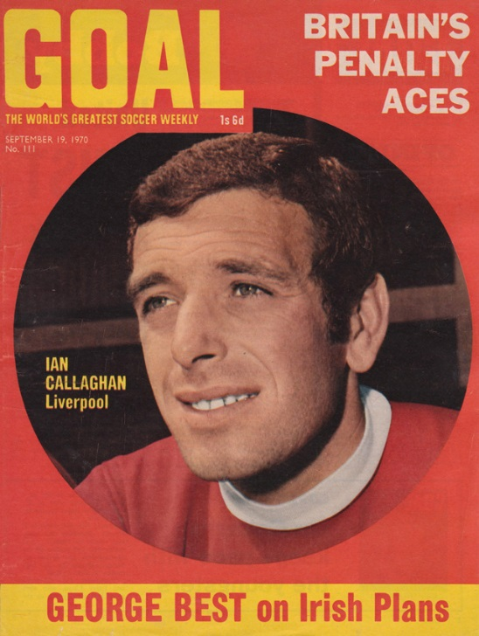

Articles:

For my articles I did a lot of research in order to find out more about my chosen topics. For example, when I wanted to write about grassroots football, I chose to interview a real grassroots manager in order to get his opinions and experiences in my magazine. Without my primary research I would not have been able to get this kind of personal view on the subject and would have been forced to get information from a website which doesn’t have the same first-hand view as my source did. For my Ronaldo article I used a variety of websites to find out information about his career. Wikipedia was a good starting point and made getting other websites easier. I also researched quotes about him on another website In order to make the article more interesting. I feel this made a huge difference to my overall piece and helped me to expand the knowledge of my readers, which was one of the aims of this article. Another of the websites I used for this project is transfermarkt, as it goes into a lot of detail about Ronaldo’s career stats and who he played for. Without this website I would have struggled to record the amount of numerical data on Ronaldo that I have in my magazine.

CHAPTER 5

My Project

Introduction
In this chapter I will discuss what I did in each stage of creating my magazine from pre-production through to post production.

Pre-Production

During my pre-production I had to do all of my research after considering what articles I wanted to write and what I wanted my design to be. I concluded that I wanted to create a football magazine with 3 main pieces and some extra additions here and there. After brainstorming ideas, I decided to create a mind map and wrote down 10 ideas for articles that I could write. I considered how difficult the research would be for each idea and how much information I would be able to get. After much consideration I came up with my final 3 ideas, however 1 of them quickly went wrong. One of my plans was to interview a friend who is a rising star in grassroots football, however it turned out he was away playing in Sweden so I had to adapt. I overcame this challenge by tweaking my idea so that I interviewed a grassroots manager. This meant I could still do my interview, whilst retaining the grassroots factor of my magazine.

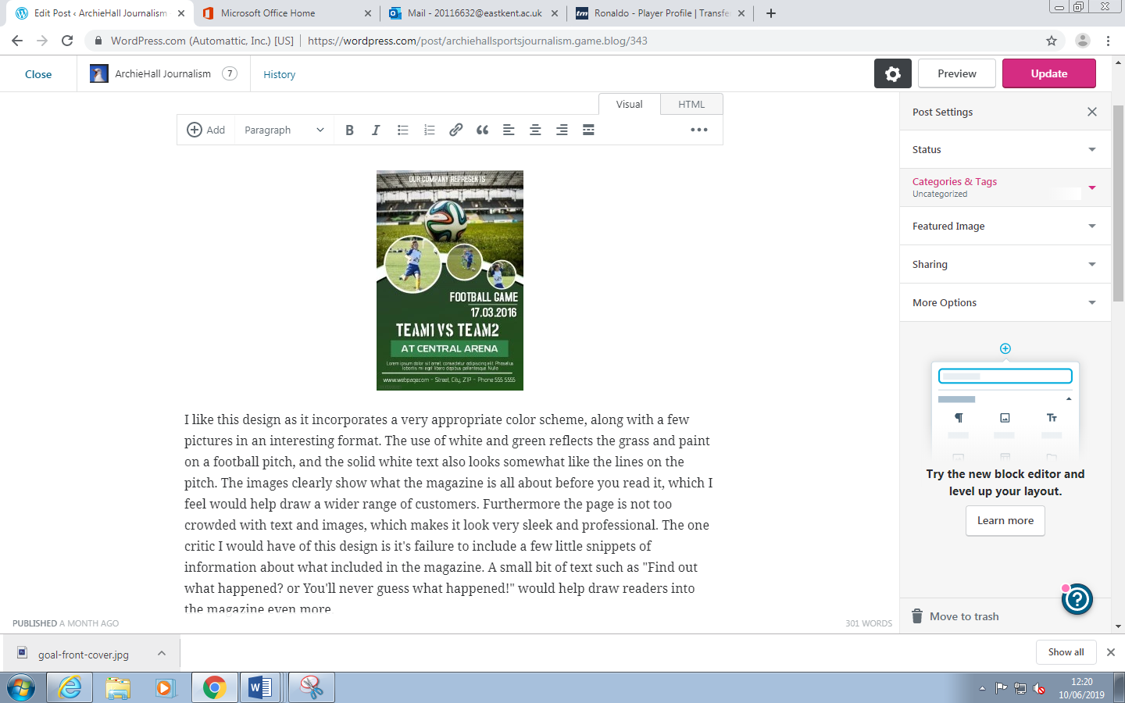
Here is an example of the analysis I did when researching designs

Production

During production I used all of my adobe InDesign and Photoshop skills that I have leaned on my course this year. I began by setting up a master page on InDesign which would give me a consistent page spread and searched the internet for some high quality photographs that I could use. Using my research on magazine design, I created the layout and front cover of my magazine within a week and proceeded to add some extra details that would make my product look professional. I created some fact files about players and page markings that flowed consistently throughout each page of my magazine. After doing all the designs, I added my articles that I had written prior to creating my magazine. Using some of the features on InDesign, I managed to make my text sit nicely around the images I had used to give my product a high quality finish. I also sent my work to my course tutor for him to mark and comment on, telling me what to improve. From these comments I made changes to my work and added some more important details that I wouldn’t have thought of before. I consistently made sure to save my FMP on both my computer and OneDrive in order to avoid losing my work if the system crashed.

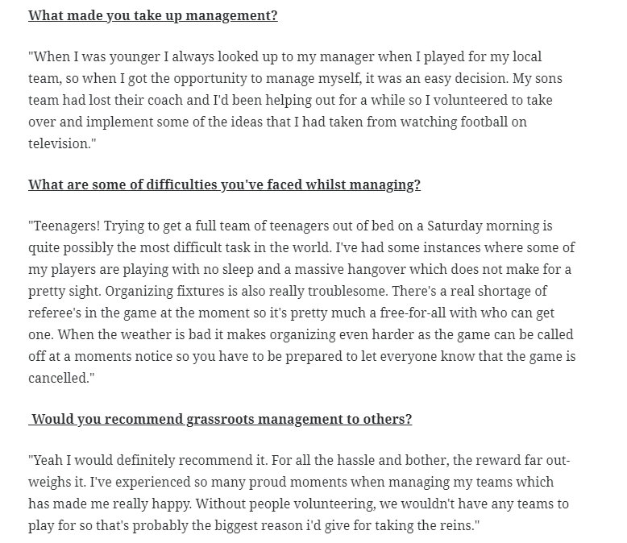
Here is the transcript for my interview

Post-production

After production I submitted my product to my course tutor so that he could give me his opinions on it. Here are some of my comments:
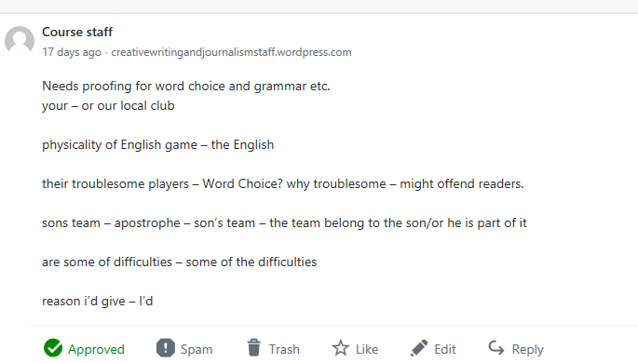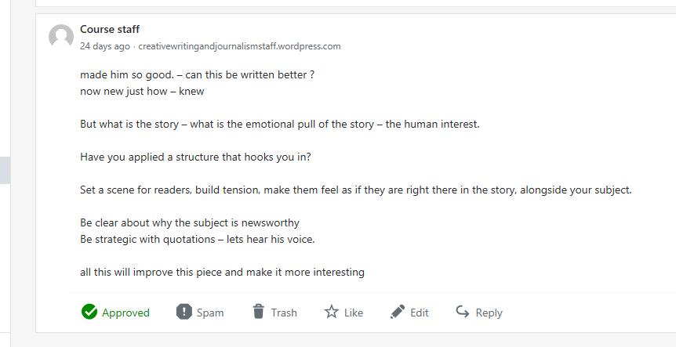
After reading these comments I acted swiftly to address the issues by proof reading and correcting the mistakes that he had pointed out. This was all completed before I uploaded my FMP onto Flip HTML and finalised for marking.

CHAPTER 6

MY FMP – FINAL PRODUCT

Here is the link to my final product: http://online.fliphtml5.com/zhnv/erwa/

CHAPTER 7

Project Evaluation

My FMP is an online football magazine that features 3 main pieces. I have written a match review, player profile and done an interview with someone heavily involved in amateur football. There are some positives and negatives to my FMP. Firstly I believe my magazine is well designed, interesting, informative, unique and sticks to my desired target audience. I do however believe that I could have put together more articles, used some better pictures, used more interactive elements, widened my target age and been done quicker. The design I chose was influenced by the 1970’s magazine ‘GOAL’, which I had researched heavily in my pre-production. It consists of a bright red background with a central image and bold black text. I wanted my magazine to look very similar, so I even researched the exact colours I would need to create an identical product. Before writing my articles I experimented with various ideas. I created a mind map and looked at how much information I could find on each subject. This helped me to choose articles, knowing that I would easily be able to find a solid amount of information about each one.
When comparing my magazine to another such as ‘Match Of The Day’, I can instantly see how my magazine Is more visually appealing. The other magazine is messy with lots of images crammed onto the front cover. The title doesn’t stand out from the background either, making it harder to recognise. In comparison, my design is much neater and more structured. The title is easily visible against the background, and the single central image relates to the article within, therefore giving the reader an instant idea of what to expect. In terms of articles, I feel that mine are far more informative. The articles in MOTD are full of very basic information that most football fans already know. I do however feel that their interviews are better than mine as they have asked a lot more questions and managed to get more information out of the people they have talked to. I also feel that my articles offers more of journey when being read, especially in my piece on Ronaldo. I do this through the use of active vocabulary such as strong verbs. This helps convey the raw emotion of the characters in my articles, and is something that I feel many professional magazines do very well.
Some of the key areas of development in my project were my design and my Ronaldo article. My design developed from a carbon copy of ‘GOAL’ to something with my own personal features. The addition of the yellow strip on the bottom of the cover adds another layer of colour to the magazine that I felt was lacking previously, along with the use of a different shade of 70’s red. Within my magazine I feel that my contents page developed significantly. It began as a simple bullet point page before turning into an intricate design featuring bold lettering and segregating lines. The Ronaldo article developed significantly after comments from my tutor. I was told to turn the article into more of a story instead of just facts. To do this I researched individual comments about his career and made my writing more dramatic through the use of rhythm and tone. I feel this made my writing far more enjoyable as the contrast in tones allowed people to experience the highs and lows of his career. Looking back at my proposal, my magazine is significantly different. I originally planned to have a magazine dedicated to grassroots football, however I couldn’t find enough information to allow me to do this, thus I decided to change my theme to professional football. I did however manage to keep to the plan in some ways as I did feature a grassroots interview as a ‘special’ and uploaded my magazine in Flip HTML. One thing I do regret not is putting the names of the footballers on my posters as some people may not know who these people are. It is not a major issue but it would still have been a nice touch.
When I asked a friend, who was in my target audience, to read my magazine they responded positively. I was told that they had learned many new things from reading my articles, which made me very happy as that was one of my aims. When pitching my idea to my lecturer I also got a good response. I was told that my classic design was very unique and that my pieces were well written and informative. Overall it went better than expected however I do feel that with better time management I could have added even more pieces to my magazine. In conclusion I feel that my piece is definitely suitable for the aims of the brief. I have created an informative, interactive piece that suits my target audience.

APPENDICES

Extended project in creative media production Learning Outcomes and Assessment

1. Understand the requirements of a creative media production project.
1.1 Analyse the requirements of a creative media production project.

2. Be able to use research methods to inform ideas for creative media production.
2.1 Review a range of research sources to support a creative media production project.
2.2 Interpret research to develop ideas and effectively communicate to an audience

3. Be able to use skills, knowledge and understanding in the completion of a creative media project.
3.1 Apply practical skills, knowledge and understanding to complete a creative media project within an agreed timeframe.

4. Be able to evaluate a creative media project.
4.1 Critically evaluate a creative media project against the agreed requirements and parameters.

REFERENCES

Make sure you use Harvard referencing. The bibliography should be continuously updated as the project progresses.

Anon., 2017. BBC News. [Online]
Available at: http://www.bbc.co.uk/
Smith, c., 2017. Fun with Flags. 5 ed. canterbury: media.

Anon., 2017. BBC News. [Online]
Available at: http://www.bbc.co.uk/
modley, a., 2017. fun with face. 5 ed. canter: zoran .
Smith, c., 2017. Fun with Flags. 5 ed. canterbury: media.

